Name(s)_______________________________________________ Period ______ Date ___________________
 | Project Guide - Human Device Interaction | 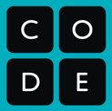

Overview
Many physical devices now have apps that let us control them from afar, like turning on a thermostat or turning off the lights from their own app. These devices also tend to have additional physical materials, like a colorful enclosure or written labels next to the lights, that improve the usability and style of the device.

In this project, you will create an app that controls the circuit playground so it can interact with the physical environment around it. Your app should use the screen elements primarily for input (as if you are using an app on your phone), and the circuit playground for output (as if you’re controlling a device from far away).

You should use physical materials from your environment (such as paper or cardboard or other materials) to help you create your device. These materials can add structure to your device, improve the function of your device, or give more information to the user outside of the app or device.

Brainstorm: Program and Device Design
Start by thinking about the purpose of your app and how it should incorporate the circuit playground and the physical environment. How will the user interact with it? How does it communicate back to the user? What will it look like on the app and physically in your environment?

Write a 2-3 sentence description of your app and how it works with the circuit playground

Sketch Your App and Device
Describe your device and roughly sketch out the main elements. Don’t worry about making it pretty.
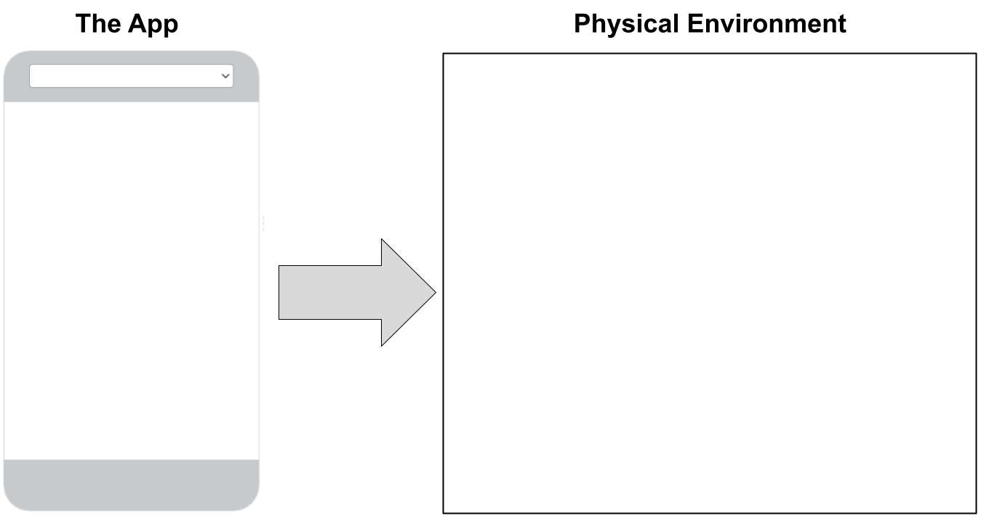

Materials
List any materials you will need to build your device

Inputs
What inputs will your device use? Will they be on the app (like buttons or dropdowns), or on the circuit playground (like the toggle switch or buttons)

Input type | Location | What is it used for?
- Screen
- Board
- Screen
- Board
- Screen
- Board

Outputs
What outputs will your device use? Will they be on the app (like labels or screens), or on the circuit playground (like LEDs or the buzzer)

Output Type | Location | What does it do?
- Screen
- Board
- Screen
- Board
- Screen
- Board

Develop Your Device

Once your teacher has approved your design, use the materials you are given to develop your device.

Test Your Device

Test your device with multiple users and, if time allows, incorporate feedback from your testing.

Reflect

What part of your project are you most proud of? ____________________________________________________

Why? _______________________________________________________________________________________

_____________________________________________________________________________________________

If you had more time, what improvement would you make to your innovation?

_____________________________________________________________________________________________

_____________________________________________________________________________________________

